Documentation of Salary-api (OT-MICROSERVICES)

- After creating an instance, first is to update the packages (instance type t2.large volume 20GB)

sudo apt update

- Now, clone the salary-api repo in your instance

git clone https://github.com/OT-MICROSERVICES/salary-api.git

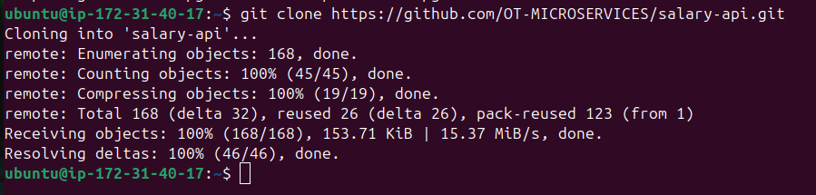

- Now, install all the prerequisites required for salary-api

  - Scylladb Installation and configuration

    - Install a repo file and add the ScyllaDB APT repository to your system.

sudo mkdir -p /etc/apt/keyrings
sudo gpg --homedir /tmp --no-default-keyring --keyring /etc/apt/keyrings/scylladb.gpg --keyserver hkp://keyserver.ubuntu.com:80 --recv-keys A43E06657BAC99E3 491c93b9de7496a7

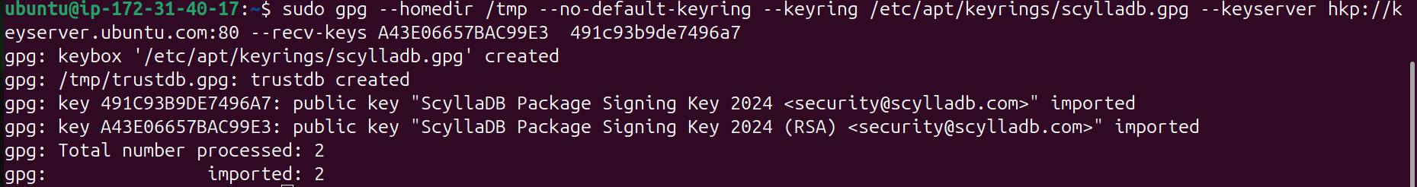

sudo wget -O /etc/apt/sources.list.d/scylla.list http://downloads.scylladb.com/deb/debian/scylla-6.2.list

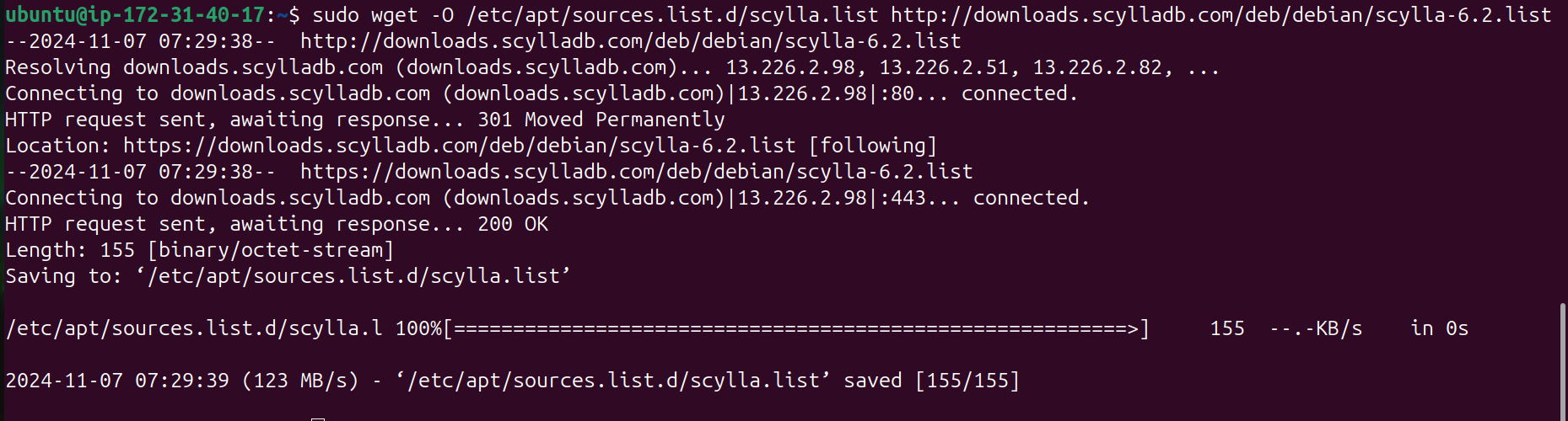

2) Install ScyllaDB packages.

sudo apt-get update

sudo apt-get install -y scylla
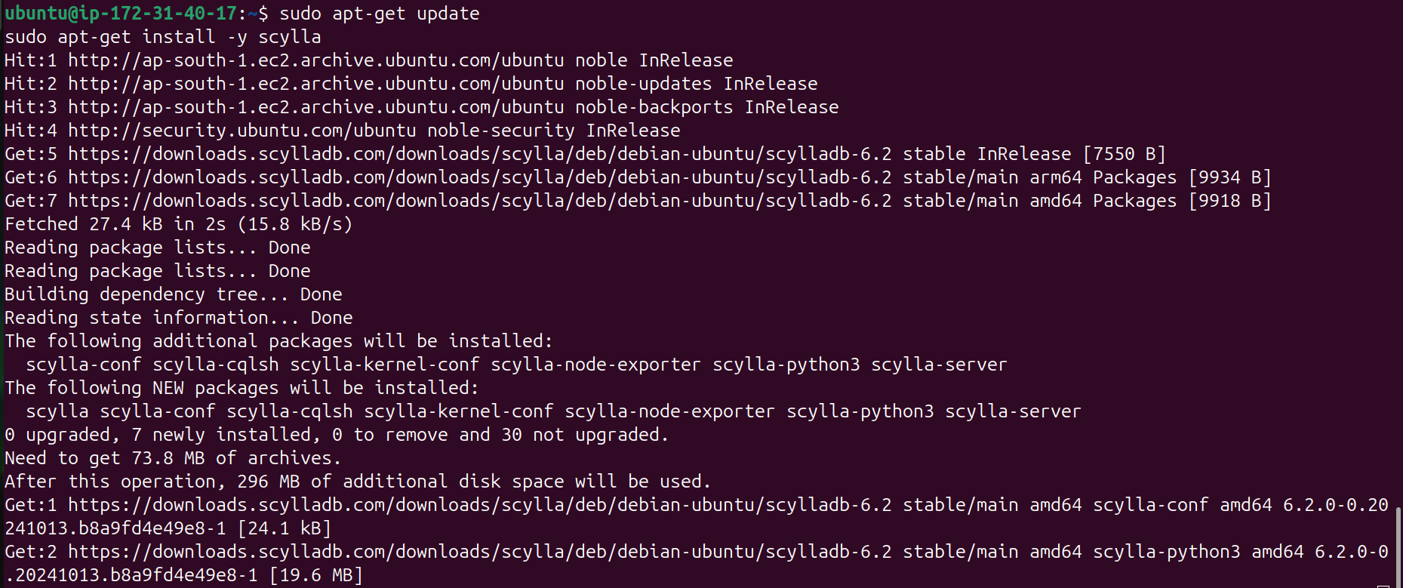
3) Configure I/O settings for ScyllaDB on your VM.

sudo /opt/scylladb/scripts/scylla_io_setup

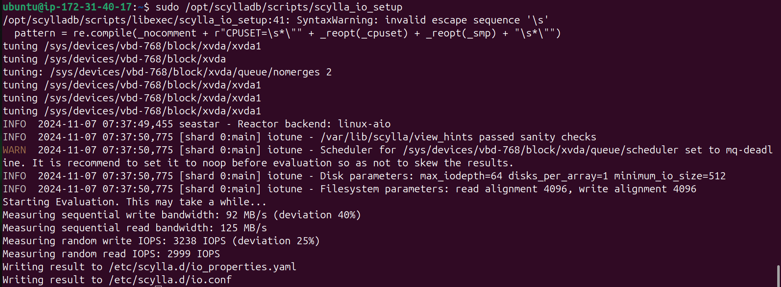

4) In the configuration file of scylla do the following changes

Path of scylla.yaml:-yes
sudo /opt/scylladb/scripts/scylla_io_setup
- Add this line for access control and permission
Add the below in first line of above file
authenticator: PasswordAuthenticator

authorizer: CassandraAuthorizer

b) Now mention rpc address (Your Private IP)

rpc_address: 172.31.40.17 (line 222)

The rpc_address defines the IP address that clients (such as application servers or other services) should use to connect to the ScyllaDB node.
Clients communicate with the database cluster through this address, making it crucial for client-server communication.

5) Restart the scylla-server service

sudo systemctl restart scylla-server.service

6) Now enter into scylladb using below command

cqlsh 127.0.0.1 9042 -u cassandra -p cassandra

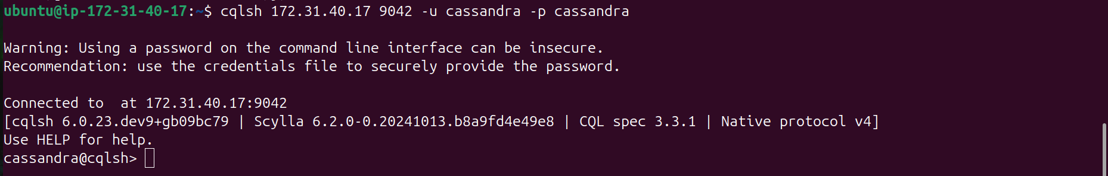

7) Create user ‘scylladb’ with password as ‘password’

CREATE USER scylladb WITH PASSWORD 'password' SUPERUSER;

8) Check users list in scylladb

LIST USERS;
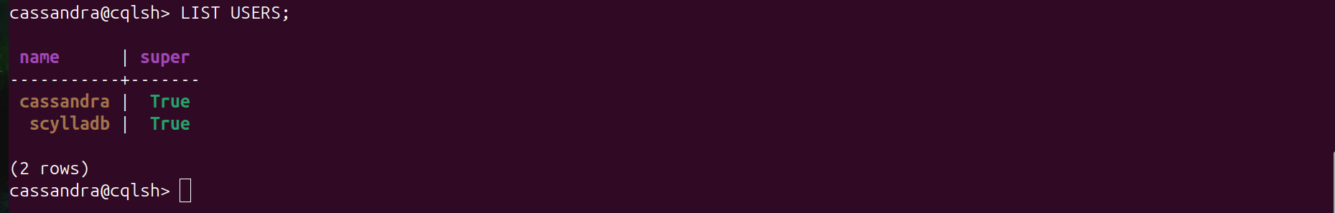

9) Create keyspace employee_db

CREATE KEYSPACE employee_db WITH REPLICATION = { 'class': 'SimpleStrategy', 'replication_factor': 1 };

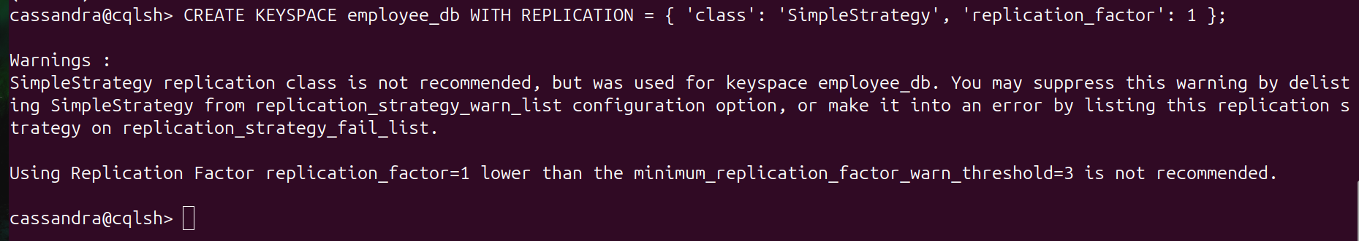

10) Check whether the employee_db

DESCRIBE KEYSPACES;

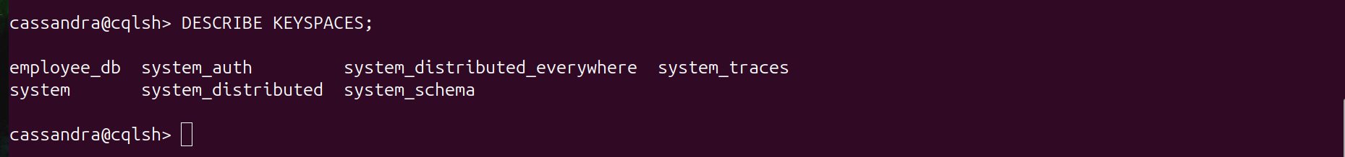

Data base dekhana ho to

11) USE employee_db ;
12) DESCRIBE TABLES;

13) SELECT * FROM employee_info ;
Salary ke liye :

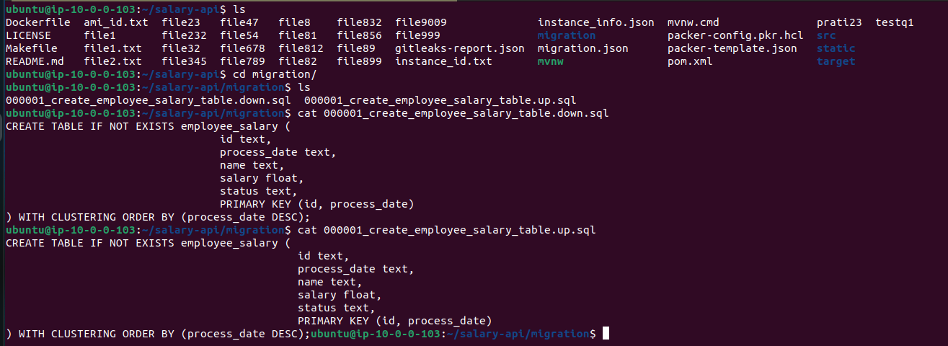

B) Redis Installation and Configuration

- Install redis

sudo apt update

sudo apt install redis-server -y

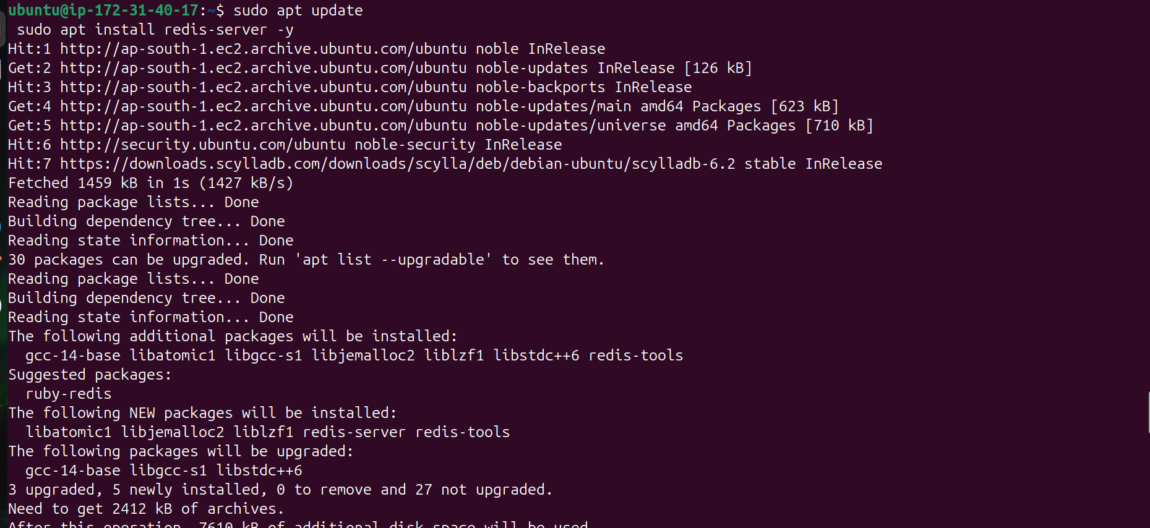

- Configuration of redis : Enter into redis

redis-cli

3) Configure user permissions and authentication settings in redis

ACL SETUSER scylla on >password ~* +@all

4) List the acl to check whether it is updated or not

ACL LIST
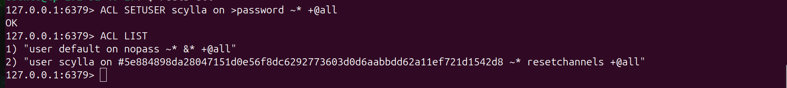

C) Install Maven

- Now install maven using below command but before that install java 17

sudo apt update

sudo apt install openjdk-17-jdk -y

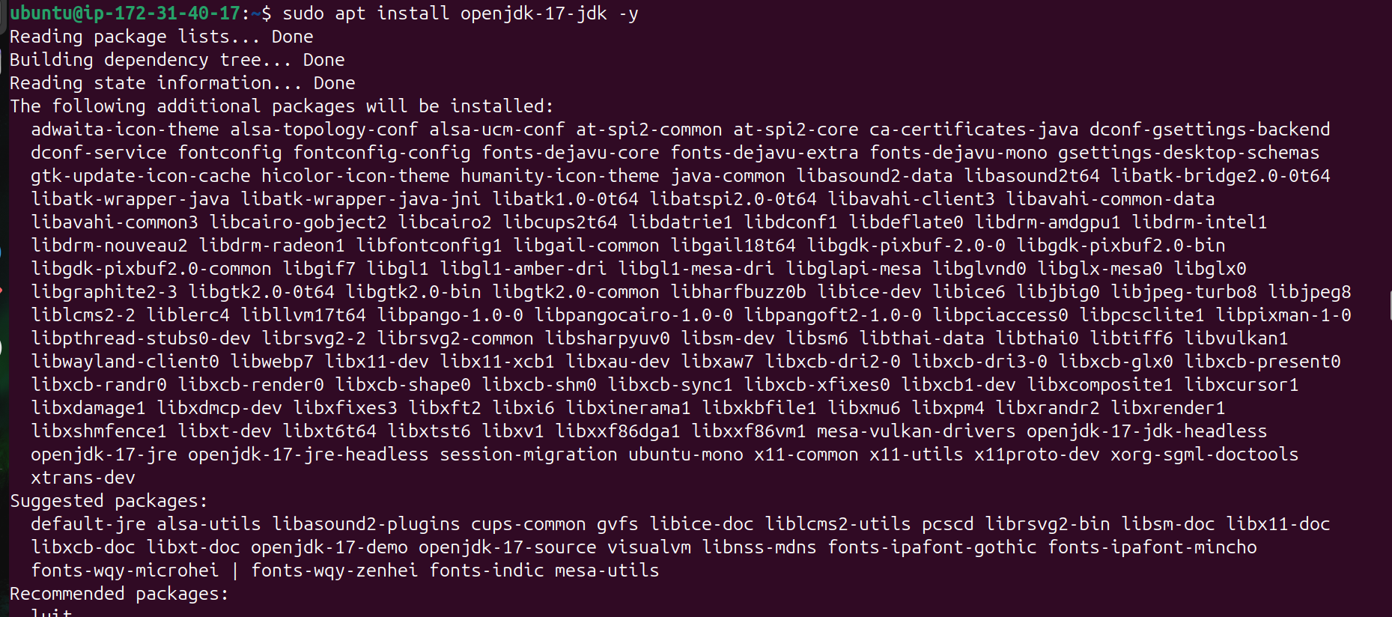

sudo apt install maven -y

- Enter into salary-api directory and change the ip address in application.yaml to your private ip address

- Enter into src/main/resources/

cmd: - sudo vi src/main/resources/application.yml

- Enter into src/test/resources/

Cmd: -sudo vi src/test/resources/application.yml

3) Create the service file for salary-api service

Path: - sudo vi /etc/systemd/system/salary-api.service

The service file is as follows

[Unit]
Description=salary api
After=network.target

[Service]
Type=simple
User=ubuntu
Group=ubuntu
WorkingDirectory=/home/ubuntu/salary-api/
ExecStart=java -jar /home/ubuntu/salary-api/target/salary-0.1.0-RELEASE.jar --server.port=8081
Restart=on-failure
RestartSec=5
StandardOutput=journal
StandardError=journal

[Install]
WantedBy=multi-user.target

4) Enable and start the salary-api service

sudo systemctl enable salary-api.service

sudo systemctl start salary-api.service

4) Restart the salary-api service

sudo systemctl restart salary-api.service

D) Install migration tool

- Download the zip file of the migration tool(migrate)

curl -L https://github.com/golang-migrate/migrate/releases/download/v4.15.2/migrate.linux-amd64.tar.gz | tar xvz
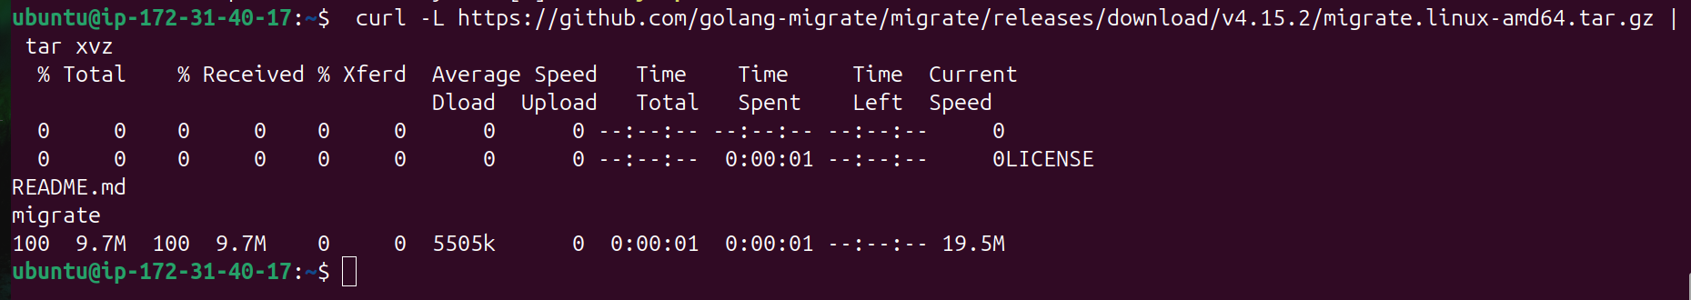

- Move the file to below location

sudo mv migrate /usr/local/bin/migrate

- Check the version of migrate

migrate --version

E) Now enter into salary-api directory and run the clean package

mvn clean package

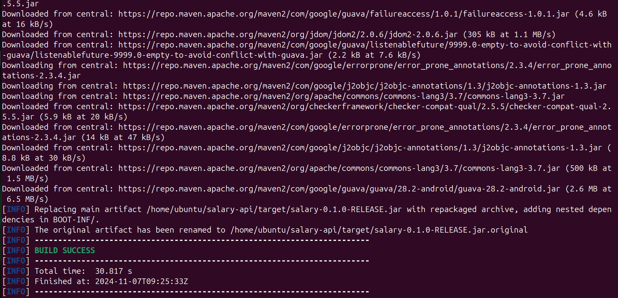

F) Install make command

sudo apt install make

G) Change the ip address into migration.json file in salary-api directory

F) Now run the migration command

make run-migrations

H) Finally run the java runtime command

java -jar target/salary-0.1.0-RELEASE.jar

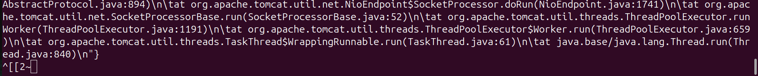

FINAL OUTPUT
